

Packet tracer Activity 4: Classful IP Addressing and Network Interconnection

The North-West University (NWU) has appointed your startup networking company SWITCH NETWORKS to design and implement an IP addressing scheme for its three campuses. Each campus currently operates a local area network (LAN) using legacy devices configured with classful IP addressing.
Due to infrastructure limitations and compatibility requirements, the university has decided to continue using classful addressing. However, the current network lacks proper configuration to allow communication between campuses.
SWITCH NETWORKS has been tasked with organising the IP addressing scheme using appropriate classful address ranges and ensuring full interconnectivity between the three LANs.

LAN | Device IP address | Smallest IP Addr  (gateway) | Broadcasting IP Addr | Largest IP Addr  (PC-2)
Mahikeng | 192.168.3.2 | 192.168.3.1 | 192.168.3.255 | 192.168.3.254
Potch | 192.168.2.99 | 192.168.2.1 | 192.168.2.255 | 192.168.2.254
Vaal | 192.168.1.120 | 192.168.1.1 | 192.168.1.255 | 192.168.1.254

Interconnectivity test: Attach a screenshot for each.

Vaal-PC-2 ping Mahikeng-PC-2
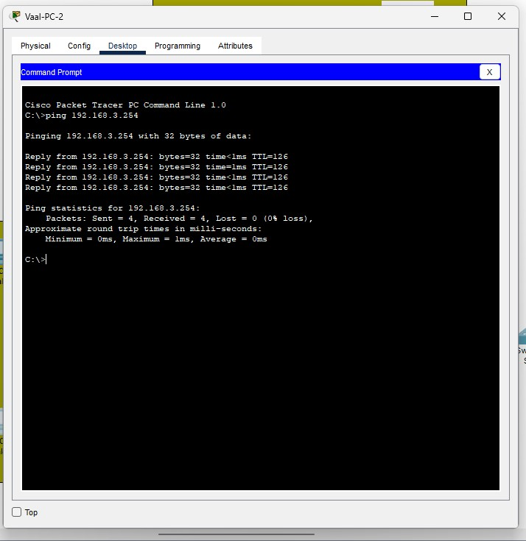

Vaal-PC-2 ping Potch-PC-2
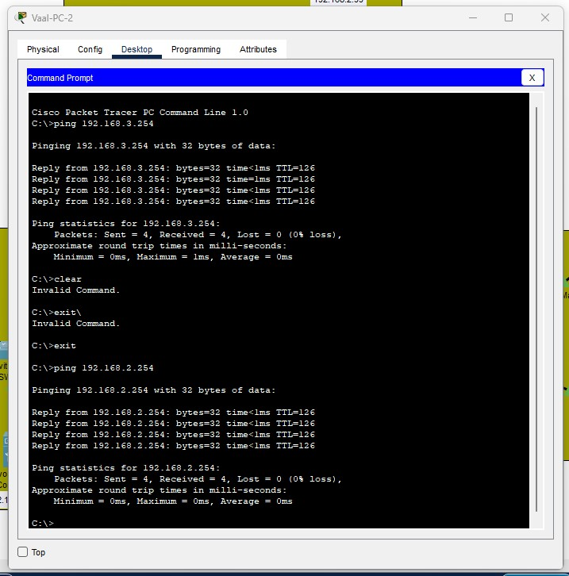

Potch-PC-1 ping Vaal-PC-1
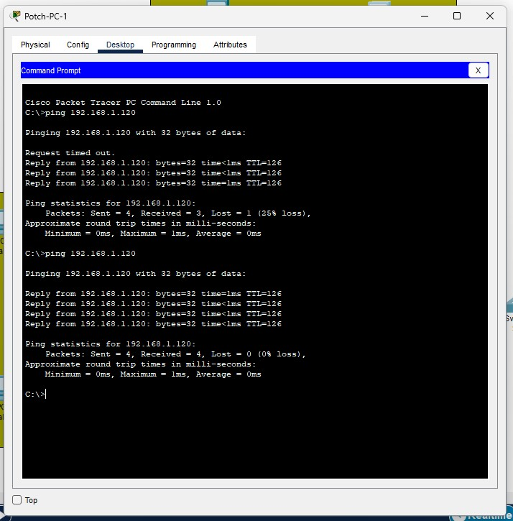
_________________________________________________________________________________
Submit a MS Word document named StudentNum_LabPCNum_Surname

